
PRACTICAL ASSESSMENT TASK

Name : Mbasa Batyi
GRADE : 11 G
District : CHRIS HANI DISTRICT
teacher : MR Muza
topic : tUCKSHOP MANAGEMENT PROGRAM

queens college boys high school |mbatyi@queenscollege.co.za

INFORMATION TECHNOLOGY
2023

TABLE OF CONTENTS
Contents
TABLE OF CONTENTS 1
TASK DEFINITION 4
USER REQUIREMENTS 5
USER 5
REQUIREMENT 5
REASON 5
DATABASE DESIGN 6
Purpose of the database is: 6
tblStockPurchased 6
tblStockReturns 6
tblFinances 6
tblUser 7
RELATIONSHIPS 8
FLOWCHART 9
DATA DICTIONARY 10
Purpose of the text file is: 10
Purpose of the Arrays is: 10
IPO TABLE 11
INPUT 11
MAIN PAGE SCREEN 11
MENU SCREEN 11
LOGIN SCREEN 11
SIGN UP SCREEN 11
MAIN MENU SCREEN 11
STOCK SCREEN 11
STOCK SOLD SCREEN 12
STOCK PURCHASED SCREEN 12
RETURNS SCREEN 12
FINANCE SCREEN 12
SALES SCREEN 13
FINANCIAL STATEMENT SCREEN 13
USERS SCREEN 13
PROCESSING 14
MAIN PAGE SCEEN 14
MENU SCREEN 14
LOGIN SCREEN 14
SIGN UP SCREEN 14
MAIN MENU SCREEN 14
STOCK SCREEN 14
STOCK SOLD SCREEN 14
STOCK PURCHASED SCREEN 15
RETURNS SCREEN 15
FINANCE SCREEN 15
SALES SCREEN 15
FINANCIAL STATEMENT SCREEN 15
USERS SCREEN 15
OUTPUT 16
MAIN PAGE SCREEN 16
MENU SCREEN 16
LOGIN SCREEN 16
SIGN UP SCREEN 16
MAIN MENU SCREEN 16
STOCK SCREEN 16
STOCK SOLD SCREEN 16
STOCK PURCHASED SCREEN 17
RETURNS SCREEN 17
FINANCE SCREEN 17
SALES SCREEN 17
FINANCIAL STATEMENT SCREEN 17
USERS SCREEN 17
GRAPHICAL USER INTERFACE 18
MAIN PAGE SCREEN 18
MENU SCREEN 18
LOGIN SCREEN 19
SIGN UP SCREEN 19
MAIN MENU SCREEN 20
STOCK SCREEN 20
SOLD STOCK SCREEN 21
NEW STOCK SCREEN 21
RETURNS SCREEN 22
USERS SCREEN 22
FINANCE SCREEN 23
SALES SCREEN 23
FINANCNIAL STATEMENT SCREEN 24

TASK DEFINITION

I am Mbasa Batyi, a grade 11 pupil at Queens College Boys High School in the Eastern Cape, who has been assigned by The Department of Basic Education to program and design a utilitarian system that will be cooperative with any user at the point of sale in South African school tuck shops as my practical assessment task for the year 2023. When I will be programming and designing this cooperative system, I will be using Microsoft Access to keep records and a programming language from Borland, Delphi, which originally started as a rapid application development tool for Windows. Delphi is a dialect of the Object Pascal programming language and is also a high-level programming language that supports object-oriented design and rapid application development. It is used to develop applications ranging from outcomes to mobile applications. It has more diverse features than other programming languages, and this is the reason why this will be a helpful system with the help of its components and built-in properties. The reason why I want to program and design this utilitarian system is not only because I want to get good marks for this year’s semester but also because I want to help utilize the time at the point of sale, the management of the transactions, and stock control at tuck shops in our schools. The major problem that is faced by consumers is that the transactions tend to be slow, which is not a good thing because they are time-consuming as well as not efficient. The people working at the point of sale at the tuck shop also face problems like giving too much change (float) as well as giving less change (float) to the customers, and another problem that has been picked up amongst South African schools is that they tend to lose track of their finances as well as stock control. The system will be available at Queenstown schools.

USER REQUIREMENTS

USER | REQUIREMENT | REASON
Queenstown Girls High School tuck shop manager | Design and program a helpful system to help with stock control | To prevent stock theft because past workers have been stealing stock due to less business during exams.
Owner of the private tuck shop from Queens College Boy’s High | Design and program a system that shows the financial position of the tuck shop. | To show whether is the tuck shop running at a loss or profit.
Hangklip High School tuck shop manager | Design and program a set up for float at tuck shops | To prevent giving to much change or less change.
The seller at Queens College Junior | Design and program a system for stock control | To see what is left on the shelves such that they know what to buy when they purchase stock.
The customer | Design and program system  For producing receipts | Reason is to be able to make returns of damaged goods

DATABASE DESIGN

I will be using TTControl to keep records.

Purpose of the database is:
- It is to record to stock that is left and stock that has been sold.
- It is to record the price of the bought and existing stock to check whether is the tuck operating at a loss or profit, as they purchase in bulks.
- It is to record the returns made by the customer due to expired goods and as well as unmade well items.
- It is to record the workers that will be using the system.

tblStockPurchased

Field Name | Data type | Field Size | Validation | Input Mask
ProductID | Long text | 6 | Required | N/A
Manufacturer | Short text | 10 | Required | N/A
Quantity | Long text | 6 | No | N/A
Price | Currency | 8 | No | N/A
ExpiryDate | Date/Time | 12 | <(now) | N/A
SupplierID | Long text | 12 | No | N/A

tblStockReturns

Field Name | Data type | Field Size | Validation | Input Mask
ProductID | Long text | 6 | No | N/A
Manufacturer | Short text | 10 | No | N/A
Quantity | Long text | 6 | No | N/A
Price | Currency |  | No | N/A
ExpiryDate | Date/Time |  | <(now) | N/A

tblFinances

Field Name | Data type | Field Size | Validation | Input Mask
Purchases | Currency |  | No | N/A
SoldStock | Currency |  | No | N/A
Returns | Currency |  | No | N/A

tblUser

Field Name | Data type | Field Size | Validation | Input Mask
AdminNo | Auto Number |  | “Name@AdminNo” | N/A
Name | Short text | 8 | No
Surname | Short text | 8 | No
School | Short text | 8 | No
Password | Short text | 8 | 8 characters long | N/A
Time (sign in/log off) | Date/Time | 12 | No | N/A

RELATIONSHIPS

∞
PRODUCT ID
MAUFACTURER
QUANTITY
PRICE
EXPIRY DATE

PRODUCT ID
QUANTITY
PRICE
EXPIRY DATE
MAUFACTURER

FK

PK

PK

1

STOCK RETURNS
STOCK SOLD

FLOWCHART

Help
Sign Up

Pre-adjusted statement business financial position

Menu
Main page
Login

Main menu
Expired stock (returns)
Stock purchased

Sales
Login times
Stock sold
Users
Finances (sales)
Stock

DATA DICTIONARY

TEXT FILE
I will be using USERS.txt to keep track of users.

Purpose of the text file is:
- It is to keep track of users, who uses the system designed to track the inflow, outflow and the finances of the tuckshop.
STRUCTURE OF THE TEXT FILE | EXAMPLE OF THE TEXTFILE
username#passsword#adminNo#school | mbasabatyi23#queens123#20097#qcs

ARRAYS
I will be using arrTotals, arrProfit to keep the amounts.

Purpose of the Arrays is:
- It is to keep the total and of the purchased and sold stock to calculate to show the financial position of the tuckshop.
Structurer of arrTotals | Structurer of arrProfit
arrTotals : array[1..50] of real; | arrProfit : array[1..50] of real;

IPO TABLE

INPUT

MAIN PAGE SCREEN
VARIABLE NAME | DATA TYPE | FORMAT | SOURCE | VALIDATION | COMPONETNS
 |  |  |  |  | btnProceed

MENU SCREEN
VARIABLE NAME | DATA TYPE | FORMAT | SOURCE | VALIDATION | COMPONETNS
 |  |  |  |  | ImgGHS
 |  |  |  |  | ImgQCS
 |  |  |  |  | ImgQCJ

LOGIN SCREEN
VARIABLE NAME | DATA TYPE | FORMAT | SOURCE | VALIDATION | COMPONETNS
sAdminNo | String | N/A | Keyboard | N/A | edtAdminNo
sPassword | String | N/A | Keyboard | N/A | edtPassword
 |  |  |  |  | lblSignUp

SIGN UP SCREEN
VARIABLE NAME | DATA TYPE | FORMAT | SOURCE | VALIDATION | COMPONETNS
sName | String | N/A | keyboard | N/A | edtName
sSurname | String | N/A | Keyboard | N/A | edtSurname
sSchool | String | N/A | Keyboard | Enter a valid school | edtSchool
sGender | char | N/A | Mouse | Choose a value | rgpGender
sAdmin | String | N/A | Keyboard | N/A | edtAdmin
sPassword | String | N/A | Keyboard | Password should be 8 characters long with @#!* and with the use of capital letters | edtPassword

MAIN MENU SCREEN
VARIABLE NAME | DATA TYPE | FORMAT | SOURCE | VALIDATION | COMPONETNS
 |  |  |  |  | btnStock
 |  |  |  |  | btnUsers
 |  |  |  |  | btnFinances

STOCK SCREEN
VARIABLE NAME | DATA TYPE | FORMAT | SOURCE | VALIDATION | COMPONETNS
 |  |  |  |  | btnStockSold
 |  |  |  |  | btnPurchasedStock
 |  |  |  |  | btnReturnedStock

STOCK SOLD SCREEN
VARIABLE NAME | DATA TYPE | FORMAT | SOURCE | VALIDATION | COMPONETNS
 |  |  |  |  | btnDisplay
 |  |  |  |  | redout

STOCK PURCHASED SCREEN
VARIABLE NAME | DATA TYPE | FORMAT | SOURCE | VALIDATION | COMPONETNS
sManufacturer | String | N/A | Keyboard | N/A | edtManufacturer
rPrice | Real | R00,00 | Keyboard | Round off to 2 decimal places | edtPrice
iQuantity | interger | N/A | Keyboard | N/A | spnQuantity
sExpiryDate | dtp | DD/MM/YYYY | Keyboard | <><(now) | dtpExpiryDate
sSupplierID | String | N/A | Keyboard | N/A | edtSupplierID
 |  |  |  |  | edtRecord

RETURNS SCREEN
VARIABLE NAME | DATA TYPE | FORMAT | SOURCE | VALIDATION | COMPONETNS
sProductID | String | N/A | Keyboard | N/A | edtProductID
sManufacturer | String | N/A | Keyboard | N/A | edtManufacturer
rPrice | Real | R00,00 | Keyboard | Round of to decimal places | edtPrice
iQuantity | interger | N/A | Keyboard | N/A | spnQuantity
sExpiryDate | dtp | DD/MM/YYYY | Keyboard | N/A | dtpExpiryDate
sSupplierID | String | N/A | Keyboard | N/A | edtSupplierID
 |  |  |  |  | edtRecord

FINANCE SCREEN
VARIABLE NAME | DATA TYPE | FORMAT | SOURCE | VALIDATION | COMPONETNS
 |  |  |  |  | btnFinancial Statement
 |  |  |  |  | btnSales

SALES SCREEN
VARIABLE NAME | DATA TYPE | FORMAT | SOURCE | VALIDATION | COMPONETNS
 |  |  | Textfile/databasae |  | redout
 |  |  |  |  | btnDisplay

FINANCIAL STATEMENT SCREEN
VARIABLE NAME | DATA TYPE | FORMAT | SOURCE | VALIDATION | COMPONETNS
 |  |  | Textfile/database |  | redout
 |  |  |  |  | btnDisplay

USERS SCREEN
VARIABLE NAME | DATA TYPE | FORMAT | SOURCE | VALIDATION | COMPONETNS
 |  |  |  |  | redout
 |  |  |  |  | btnDisplay

PROCESSING

MAIN PAGE SCEEN
TASK | PROCESSING
Proceed to the next screen | btnProceed

MENU SCREEN
TASK | PROCESSING
Choose GHS Choose QCS Choose QCJ | btnGHS  btnQCS  btnQCJ

LOGIN SCREEN
TASK | PROCESSING
Log in a user | tblUsers.open;  tblUsers.sort;  tblUser.last;  tblUsers[Name] : edtName.text;  tblUsers [Password] : edtPassword.text;  redirects to signup screen lblSignup:  btnEnter

SIGN UP SCREEN
TASK | PROCESSING
Sign Up a User | tblUsers.open;  tblUsers.sort := ‘AdminNo’;  tblUser.last;  tblUsers[Name] :=edtName.text;  tblUsers [Password] :=edtPassword.text;  tblUsers [School] :=edtSchool.text;  tblUsers [Admin] :=edtAdmin.text;  tblUsers[Surname] :=edtSurname.text;  tblUsers.post;  btnEnter

MAIN MENU SCREEN
TASK | PROCESSING
Stock  Users  Finances | btnStock  btnUsers  btnFInaces

STOCK SCREEN
TASK | PROCESSING
Choose Stock sold  Choose Stock Purchased  Choose Returns | btnStockSold  btnStockPurchased  btnReturns

STOCK SOLD SCREEN
TASK | PROCESSING
Display the sold stock | btnDisplay

STOCK PURCHASED SCREEN
TASK | PROCESSING
Accept Manufacturer Accept Quantity  Accept Price  Accept Expiry Date  Accept SupplierID | tblStockPurchased.open;  tblStockPurchased:= ‘ProductID’;  tblStockPurchased.last;  tblStockPurchased [Manufacture]:=edtManufacturer.text;  tblStockPurchased[Quantity] :=spnQuantity.Item[ItemIndex];  tblStockPurchased [Pricesl] :=strtofloat(edtPrice);  tblStockPurchased [ExpiryDate]:=dtpExpiryDate;  tblStockPurchased [Surname] :=edtSupplierID.text;  tblUsers.post;  btnEnter;

RETURNS SCREEN
TASK | PROCESSING
Accept ProductId  Accept Manufacturer Accept Quantity  Accept Price  Accept Expiry Date  Accept SupplierID | tblStockPurchased.open;  tblStockPurchased:= ‘ProductID’;  tblStockPurchased.last;  tblStockPurchased [Manufacture] :=edtManufacturer.text;  tblStockPurchased[Quantity] :=spnQuantity.Item[ItemIndex];  tblStockPurchased [Pricesl] :=strtofloat(edtPrice);  tblStockPurchased [ExpiryDate] :=dtpExpiryDate;  tblStockPurchased [Surname] :=edtSupplierID.text;  tblUsers.post;  btnEnter;

FINANCE SCREEN
TASK | PROCESSING
Choose Financial Statement  Choose Sales | btnFinancialStatement  btnSlaes

SALES SCREEN
TASK | PROCESSING
Displaying the sales | btnDisplay

FINANCIAL STATEMENT SCREEN
TASK | PROCESSING
Displaying the financial statement | btnDisplay

USERS SCREEN
TASK | PROCESSING
Displaying the current users information | btnDisplay

OUTPUT

MAIN PAGE SCREEN
Output | Component | Format
Redirected to Menu screen | frmMenu | N/A

MENU SCREEN
Output | Component | Format
Redirected to Menu screen GHS | frmMenu | N/A
Redirected to Menu screen QCS | frmMenu | N/A
Redirected to Menu screen QCJ | frmMenu | N/A

LOGIN SCREEN
Output | Component | Format
Message | showmessage | message

SIGN UP SCREEN
Output | Component | Format
Message | showmessage | message

MAIN MENU SCREEN
Output | Component | Format
Redirected to Stock | frmStock | N/A
Redirected to Finances | frmFinances | N/A
Redirected to Users | frmUsers | N/A

STOCK SCREEN
Output | Component | Format
Redirected to Stock Sold | frmStockSold | N/A
Redirected toStock Purchased | frmStockPurchased | N/A
Redirected to Returns | frmReturns | N/A

STOCK SOLD SCREEN
Output | Component | Format
Successfully recorded | showmessage | message

STOCK PURCHASED SCREEN
Output | Component | Format
Successfully recorded | showmessage | message

RETURNS SCREEN
Output | Component | Format
Successfully recorded | showmessage | message

FINANCE SCREEN
Output | Component | Format
Redirected to Financial Statement | frmFinancialStatement | N/A
Redirected to Sales | frmStales | N/A

SALES SCREEN
Output | Component | Format
Diplaying the sales made | dbgGrid | N/A

FINANCIAL STATEMENT SCREEN
Output | Component | Format
Displaying the transactions and as well the financial position of the business | redout | N/A

USERS SCREEN
Output | Component | Format
Diplaying the current users information | redout | N/A

GRAPHICAL USER INTERFACE

MAIN PAGE SCREEN

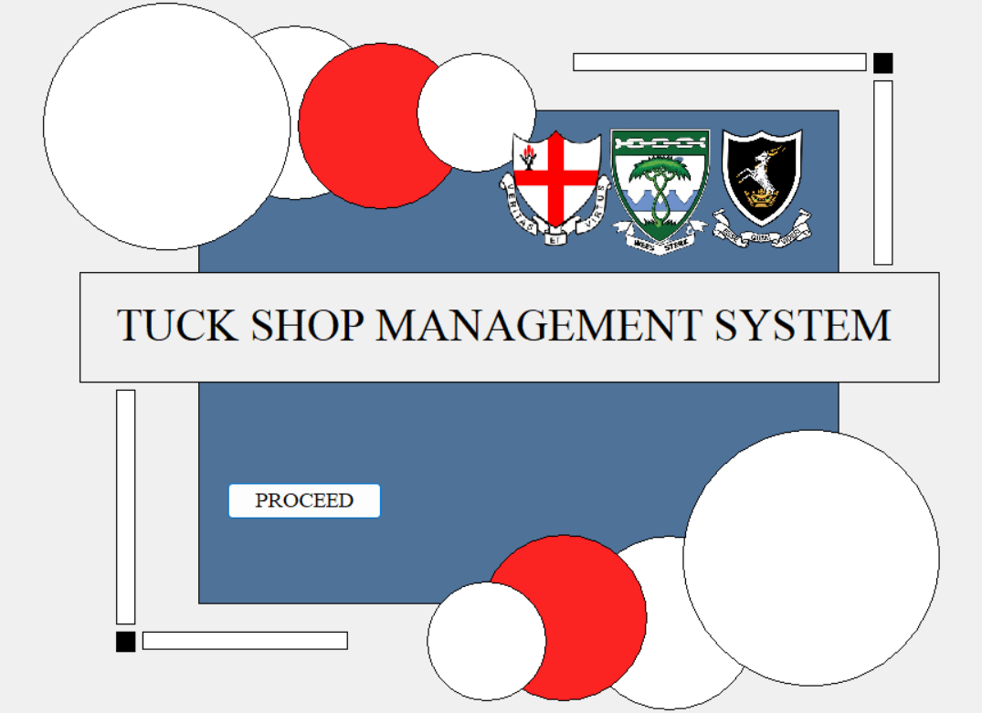

MENU SCREEN

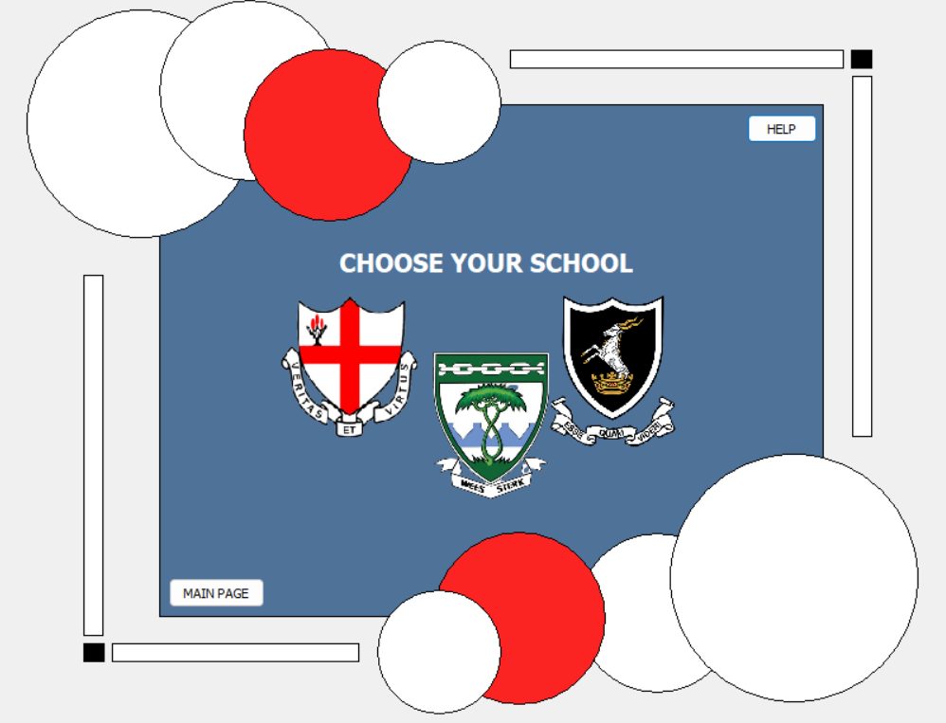

LOGIN SCREEN

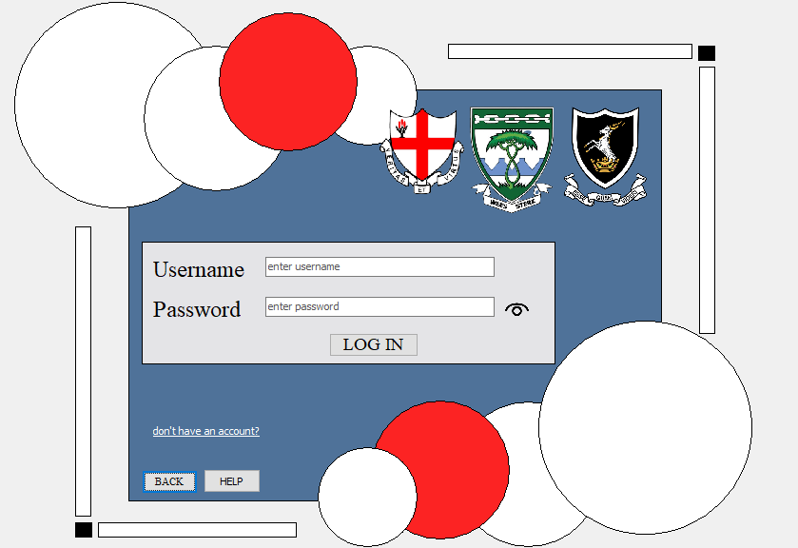

SIGN UP SCREEN

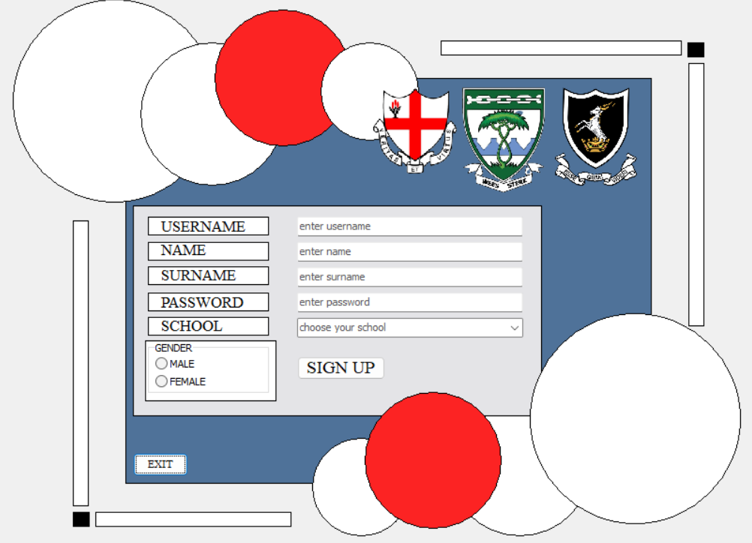

MAIN MENU SCREEN

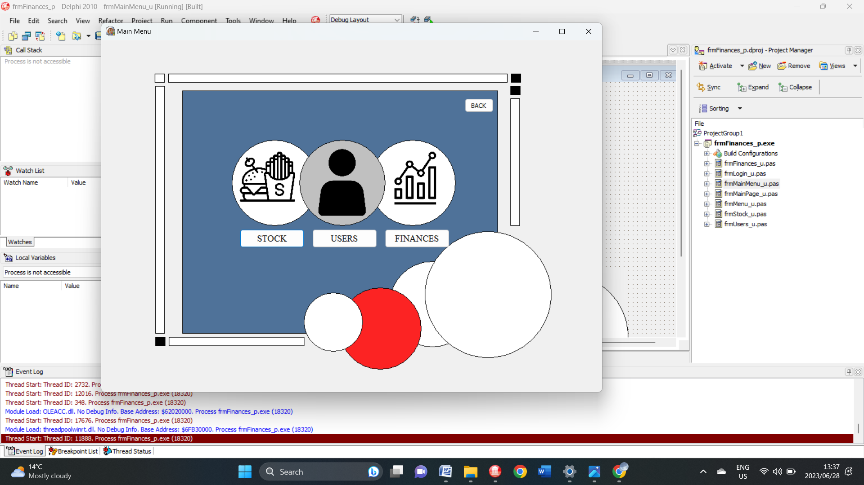

STOCK SCREEN

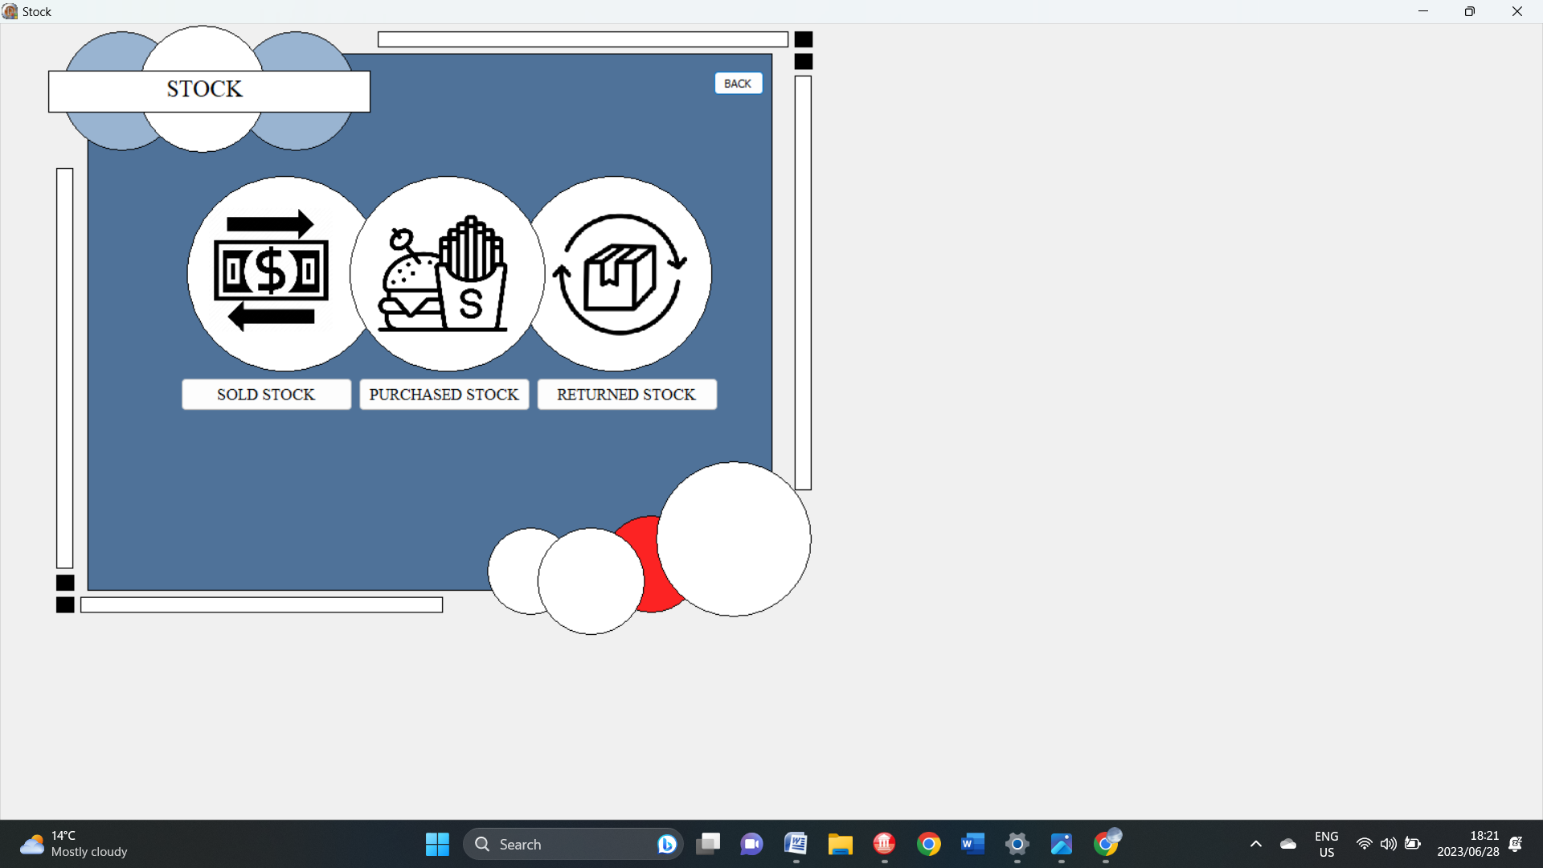

PURCHASED STOCK SCREEN
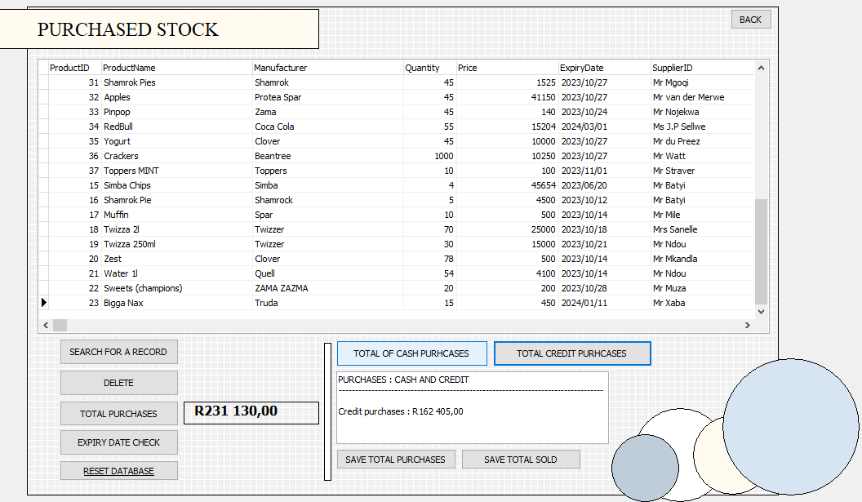

NEW STOCK SCREEN

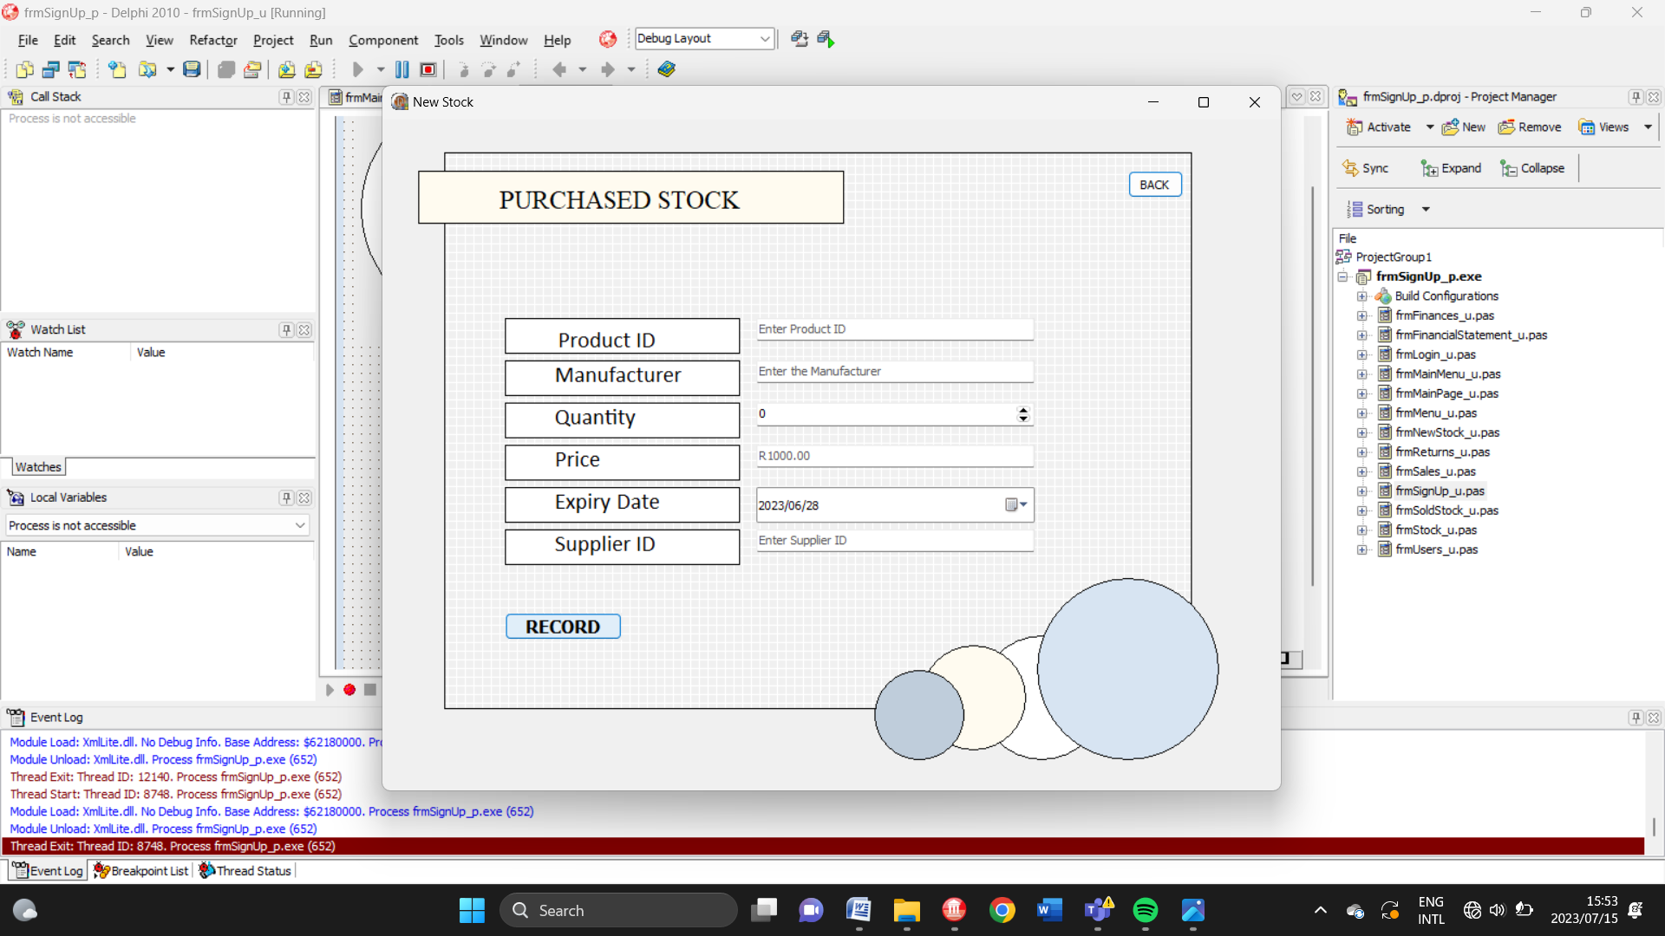

RETURNS SCREEN

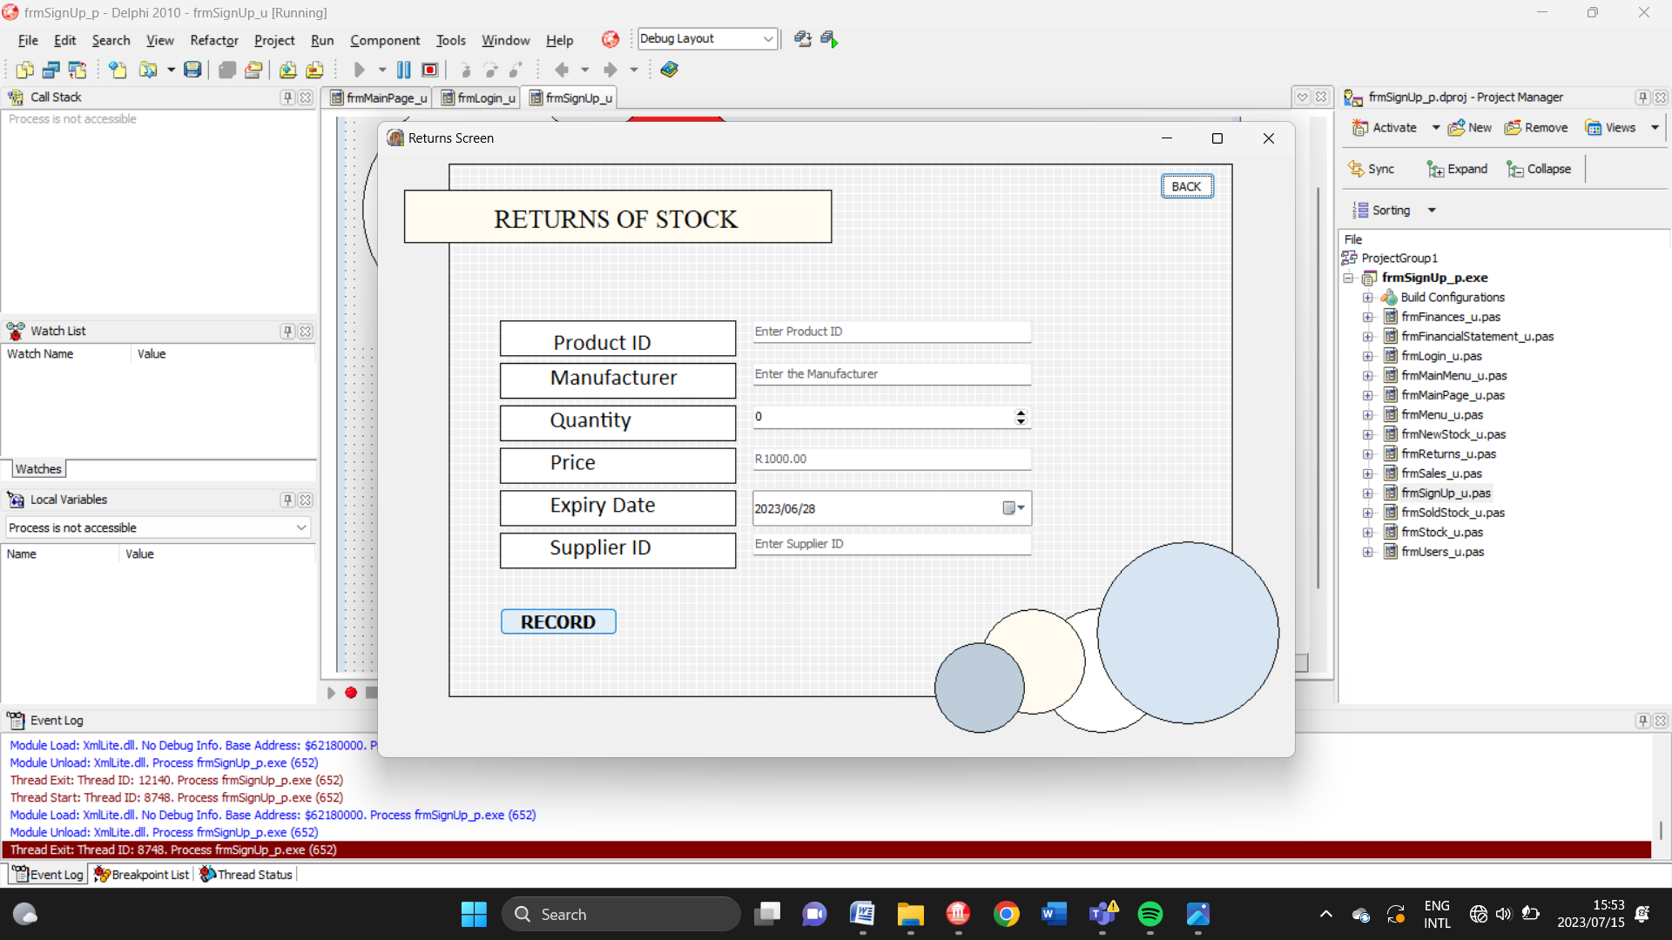

USERS SCREEN

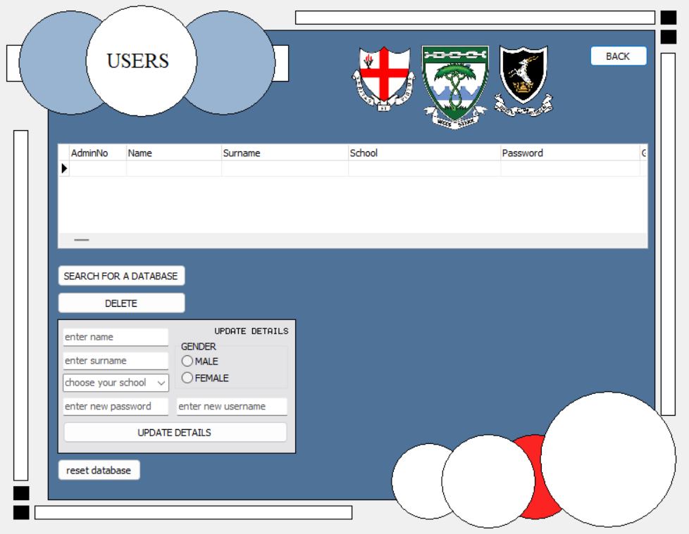

FINANCE SCREEN

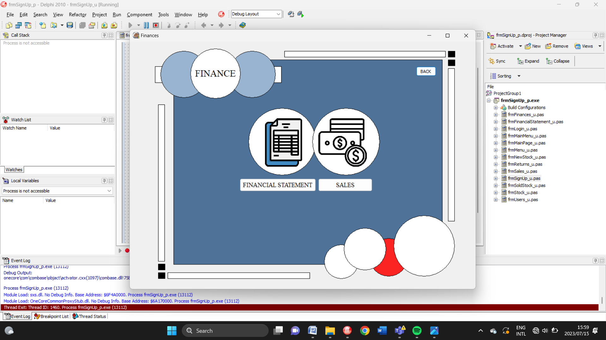

SALES SCREEN

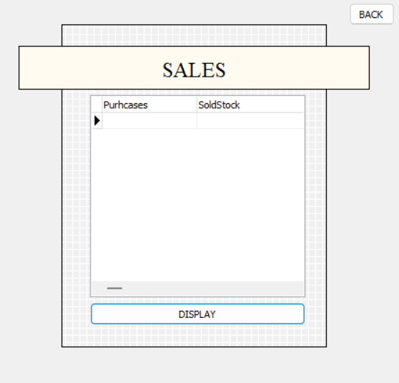

FINANCNIAL STATEMENT SCREEN

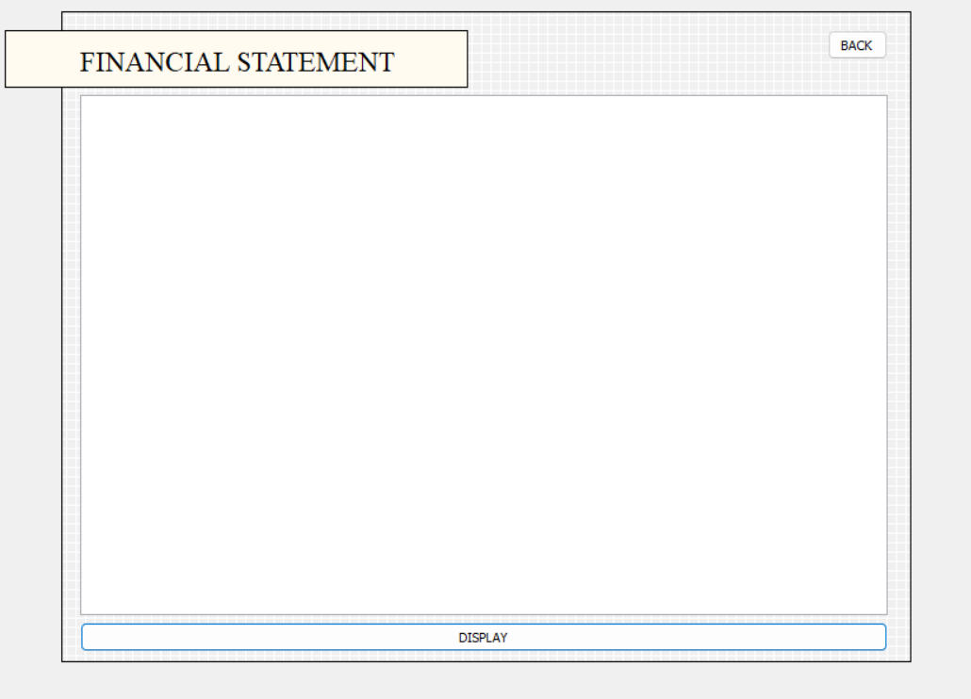

HELP SCREEN

